Create New APP

* ng new parent

Create component

* ng g c child

PARENT TO CHILD COMMUNICATION

goto app.component.html file

<div class="container">

  <h1>Component Level Interaction</h1>

  <h2>Parent Sending Data To Child</h2>

  <input type="text" (keyup)="0" #pdata >

</div>

<app-child [pdata]="pdata.value"></app-child>

Child.component.ts file

import { Component } from '@angular/core';

@Component({

  selector: 'app-child',

  templateUrl: './child.component.html',

  styleUrls: ['./child.component.css'],

  inputs:['pdata']

})

export class ChildComponent {

  pdata:string="";

}

Child.component.html

<div class="container">

    <h5>Value  Coming from Parent:</h5> <b>{{pdata}}</b>

</div>

Install the bootstrap

* npm I bootstrap

edit style.css file

/* You can add global styles to this file, and also import other style files */

@import '../node_modules/bootstrap/dist/css/bootstrap.min.css'

Save and start the app

* ng serve

goto> browser> localhost:4200

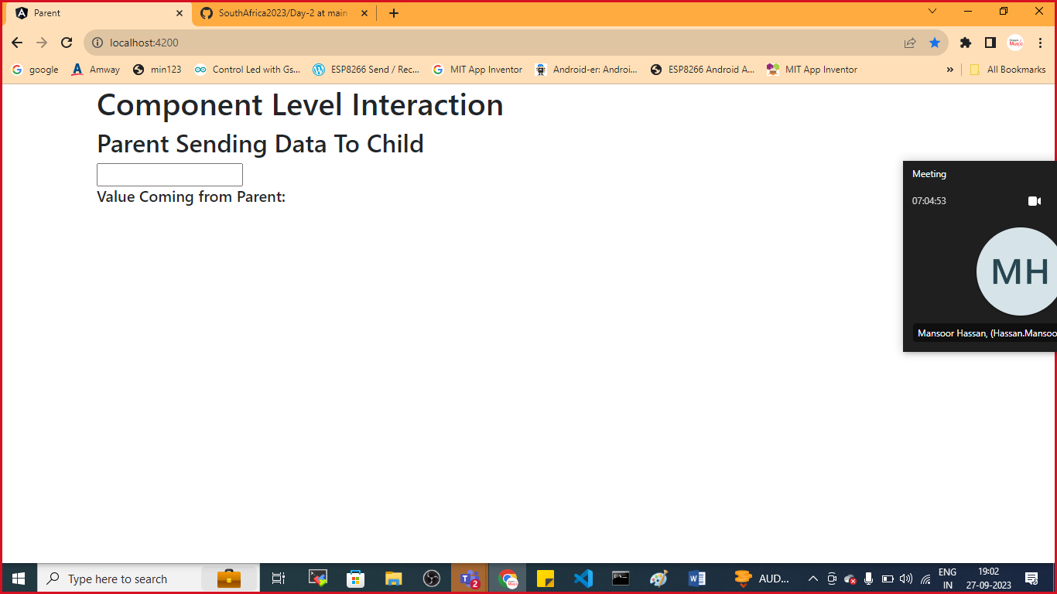

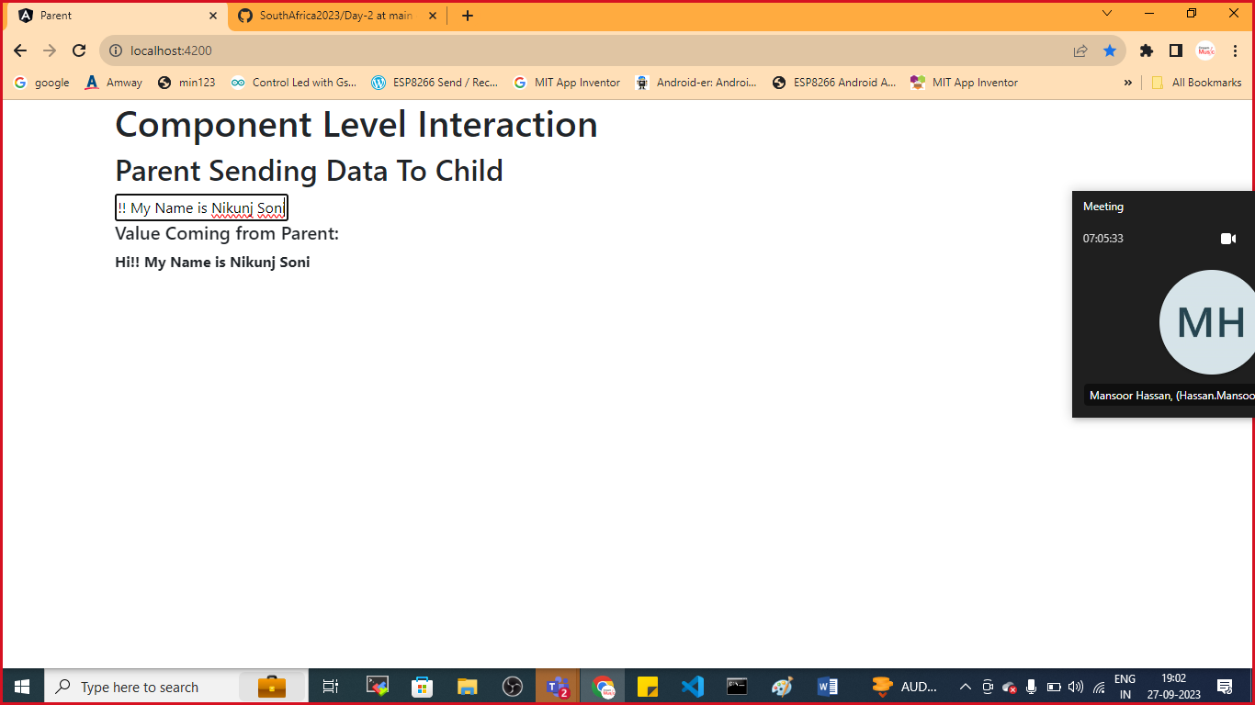

CHILD TO PARENT COMMUNICATION

Child.component.html

<div class="container">

    <h5>Value  Coming from Parent:</h5> <b>{{pdata}}</b>

</div>

<div class="container">

    <h5>Sending Data From Child to Parent</h5>

    <input type="text" #cdata (keyup)="onChange(cdata.value)">

</div>

Child.component.ts

import { Component, EventEmitter } from '@angular/core';

@Component({

  selector: 'app-child',

  templateUrl: './child.component.html',

  styleUrls: ['./child.component.css'],

  inputs:['pdata'],

  outputs:['cevent']

})

export class ChildComponent {

  pdata:string="";

  cevent= new EventEmitter<String>();

  onChange(value:string){

    this.cevent.emit(value);

  }

}

App.component.html

<div class="container">

  <h1>Component Level Interaction</h1>

  <h2>Parent Sending Data To Child</h2>

  <input type="text" (keyup)="0" #ptext>

  <h2>Value Coming from Child</h2> <b>{{cdata}}</b>

</div>

<app-child [pdata]="ptext.value"  (cevent)="cdata=$event"   ></app-child>

App.component.ts file

import { Component } from '@angular/core';

@Component({

  selector: 'app-root',

  templateUrl: './app.component.html',

  styleUrls: ['./app.component.css']

})

export class AppComponent {

  title = 'parent';

  cdata:String="";

}

Save and check the output

css you can do as per your requirement

